
School: ............................................................................................................. Campus: ....................................................... Academic Year: ...................... Subject Name: ........................................................... Subject Code: ..........................
Semester: ............... Program: ........................................ Branch: ......................... Specialization: .......................... Date: .....................................
(Learning by Doing and Discovery)
* Coding Phase: Pseudo Code / Flow Chart / Algorithm
- Launch the application or access the hashing utility.
- Enter a piece of text or message to be processed.
- Apply the SHA-256 algorithm to generate its hash value.
- Show the resulting hash on the screen.
- Modify the input text slightly.
- Run the hash function again and observe the difference from the earlier hash.
- Close or exit the program.

Coding Phase: Pseudo Code / Flow Chart / Algorithm

* Softwares used
• Online SHA-256 Tool
• Brave browser
• Internet Connection

- Testing Phase: Compilation of Code (error detection)
Test case1:
Input :- Rasheda

Hase:-b277a0e92e004177ea51420b6dd79df23f6e6a16de8ffb0bcfd438b265fcd016

Test case2 :
Input :-anjum

Hase:- 8c9eb4cd7cbaeb172c1600fadbfd0d9257589aa38b50b309205ad4ccd72a6cf2

- Implementation Phase: Final Output (no error)

Implementation Phase: Final Output (no error)
Using Online Tool
• Open SHA-256 Tool: https://emn178.github.io/online-tools/sha256.html
• Type any message
• Output hash is shown immediatel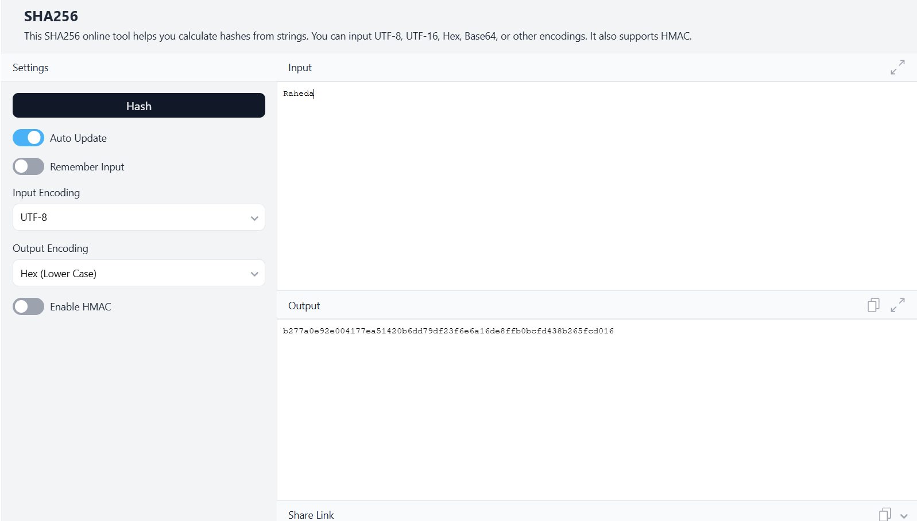

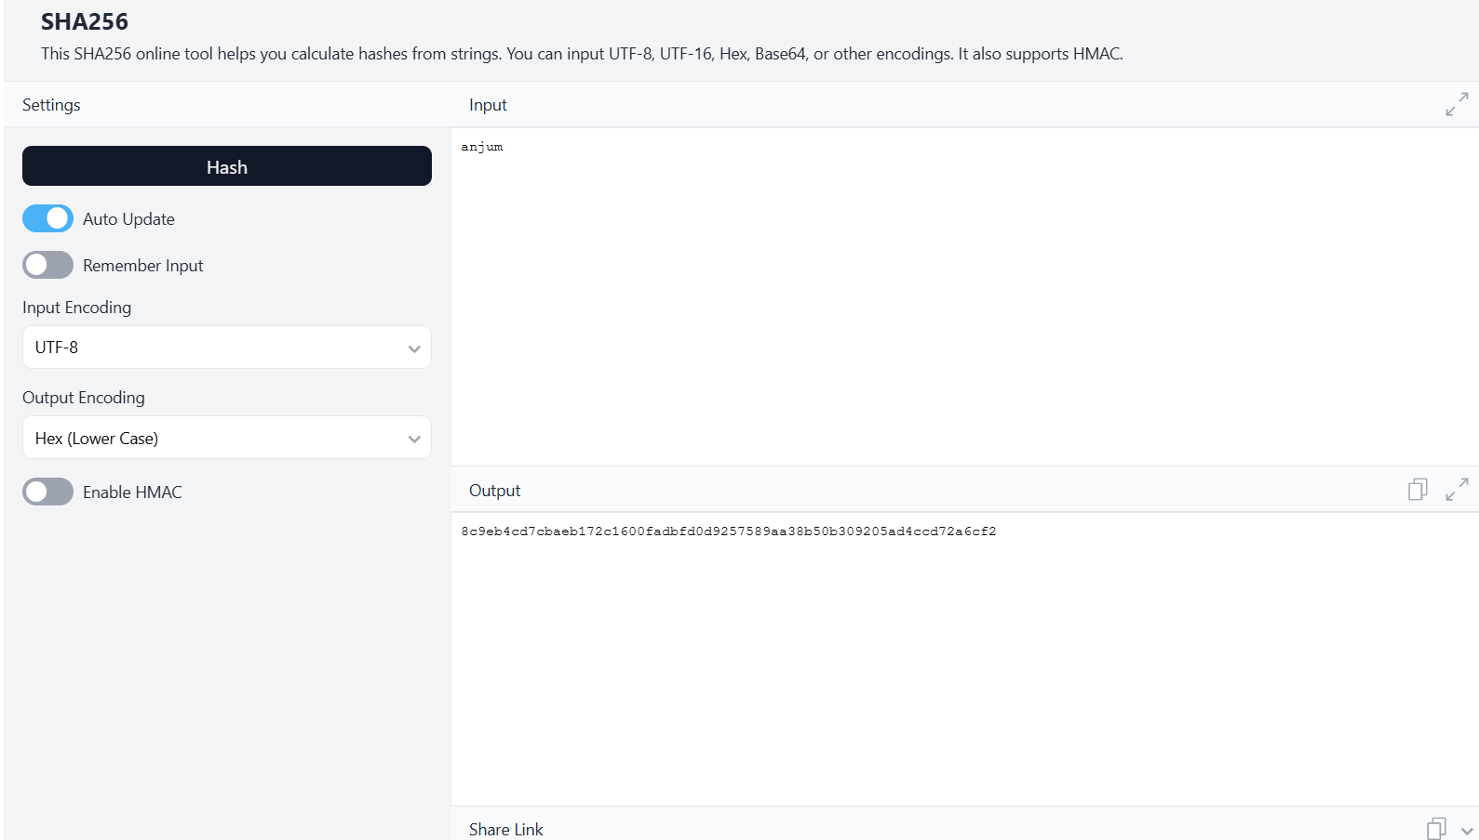

- Implementation Phase: Final Output (no error)
Applied and Action Learning

* Observations
- SHA-256 consistently produces a 64-character hash value.
- Even a tiny alteration in the input results in a drastically different hash.
- It is a one-way cryptographic function, meaning the original message cannot be recovered from the hash.
- Widely applied in blockchains, password protection, file integrity checks, and digital signatures.
- Secure, efficient, and predictable in its output.

ASSESMENT

Rubrics
Concept | 10
Planning and Execution/  Practical Simulation/ Programming | 10
Result and Interpretation | 10
Record of Applied and Action Learning | 10
Viva | 10
Total | 50


Signature of the Student:
Signature of the Faculty:

